Azure Cloud PBI

Thursday, June 3, 2021

9:32 AM

Access users to modify datalake configuration file >>the model generated results

Action:

who to move FY invoice data to cloud

Nathan to send Ben list of people name for Azure storage explore and schedule meeting to walk-through data upload

Who and how to Create a demo PBI using toy dataset

Machine generated alternative text:
Select Resource 
> Authenticate > Connect 
Select Resource 
What kind of Azure resource do you want to connect to? 
Subscription 
Sign in to Azure to access storage resources such as blobs, files, queues, and tables under subscriptions you have access to. 
Storage account or service 
Attach to one or more services in a Storage account. 
Blob container 
Attach to an individual 810b container. 
ADLS Gen2 container or directory 
Attach to an individual ADLS Gen? container or directory. 
File share 
Attach to an individual File share. 
Queue 
Attach to an individual queue. 
Table 
Attach to an individual table. 
Local storage emulator 
Attach to resources managed by a storage emulator nunning on your local machine. 
Cancel 

Machine generated alternative text:
Select Azure Environment 
Select Resource > 
Select Azure Environment > Sign In 
Which Azure environment will you use to sign in? 
C) Azure 
C) 
Azure China 
C) 
Azure Gemnany 
Azure US Government 
C) 
Custom Environment: 
Manage custom em.'ironments„. 
Back 
Cancel 

Machine generated alternative text:
ACCOUNT MANAGEMENT 
Select the tenants you want to load subscriptions 
from and the subscriptions you want to view 
resources from. 
Oshkosh Corporation-oskgows 
Remove 
U279014@oskgows.onmicrosoftus 
Oshkosh Corporation-oskgows (home 
— tenant) 
aud 585b -574d-4eb 7-be2a-eaeag3ef7b If 
up-dev -001 
9 
up-prd-OOI 
c5497fb8-6c5f-419S-b1c4-fceS6öc43a45 
up-AS-OCI 
aapdef-dev-OOI 
9464740d-c2c3-46öO-g267-82f0361788cc 
updef-prd-OOI 
bfce4ac7-984d-4e6d-8a6c-453805545b44 
aapdef-q3-OOI 
7 -a bOc-6dOdbf54d5ff 
Add an account... 
Open Explorer 
Clear completed Clear successful 
O Added Azure account '1-1279014@oskgows.onmicrosoftus' 
Apps 
C nacoradocpw01.oshkoshglobal.com/C01 
r/ popular reddit: DS Blog 
Concur 
Azu re DevOps 
advanced_analytics 
Boards 
Repos 
Files 
Commits 
Pushes 
Branches 
Tags 
Pull requests 
Project settings 
CorpDT-Advanced_Analyt 
O advanced_analyti 
azure 
advanced anal 
commerical 
datebricks_pbi 
infoworks 
meeting_minut 
• storage_explor 
> • images 
Ml installation 
on_premses 
.gitignore 
Ml readme.md 

Steps:

* Install storage explore:

[installation\_guide.md - Repos (oshkoshglobal.com)](https://nacoradocpw01.oshkoshglobal.com/CorpDT-Advanced_Analytics/_git/advanced_analytics?path=/azure/storage_explorer/installation_guide.md)

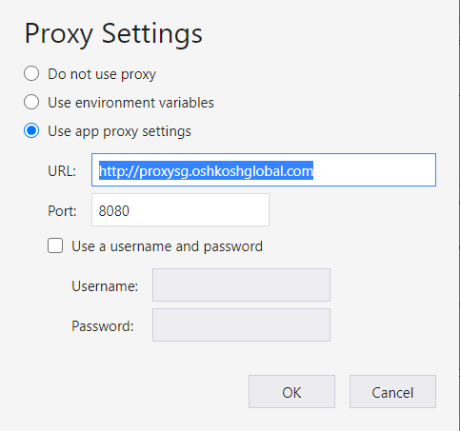

Machine generated alternative text:
EXPLORER 
Searc- for resources 
Collapse All 
Quick Access 
Local & Attached 
Storage Accounts 
S' Cosmos DB Accounts (Deprecated) 
Data Lake Storage Gen I (Preview) 
up-dev-OOI (U27g014@oskgovus.onmicrosoft.us) 
rage Accounts 
dlsaapZevf63a (ADLS Gen?) 
Blob Containers 
maindl 
test-it 
File Shares 
Queues 
Tables 
staap•amIdev556e 
staapöatchdev37d5 
staapdbwmZevOfcd 
stdIagaapdevObff 
Disks 
rg-aap-eIt-dev-1506 
rg-aap-mI-dev-2df2 
S' Cosmos DB Accounts (Deprecated) 
Data Lake Storage Gen' (Preview) 
Actions Properties 
Open 
Open New Tab 
Manage Access Control Lists.„ 
Propagate Access Control Lists„. 
Properties... 
maindl 
x 
Refresh All 
U pload 
D•cnvnload 
Open 
maincll > 
New Folder 
ml > ops 
Select AIL 
Copy 
paste 
Rename 
Mue 
ACLs 
Properties 
Delete 
Folder Statistics 
> > input_data 
Name 
C:} FY21 1 nWce Detail.csv 
Access Tier 
Hot (inferred) 
Access Tier Last Modified 
Last Modified 
6/3/2021, AM 
Refresh 
810b Type 
Block Blob 
Content Type 
application/vnd.ms-excel 
Lease Sta te 
67.8 MB 

Machine generated alternative text:
Microsoft Azure 
Databricks 
Portal 
u279014@oskgovus.onmicrosoft. 
O ? döw-aap-ml-dev-076 
config (Python) 
'-h Detached 
Cmd 1 
Searc- for resources 
Collapse All 
Quick Access 
Local & Attached 
— Storage Accounts 
Cosmos DB Acc 
Refresh All 
U pload 
Name 
Dcnvnload 
Open New Folder Select AIL 
ml/aps/d m ndOCOg66S_mIkrun/i 
Copy 
paste 
Rename 
More 
I 
4 
6 
7 
12 
13 
14 
17 
18 
21 
22 
23 
24 
25 
26 
28 
29 
30 
31 
32 
33 
34 
37 
from 
PATH 
INPUT 
INPUT 
INPUT 
INPUT 
Access Tier 
Hot (inferred) 
Access Tier Last Modified 
collect-i ons import namedtuple 
PATHS 
PATH NEEDS TO CHANGE TO LOCATION IN 
C:} FY21 1 nWce Detail.csv 
Last Modified 
6/3/2021, AN 
CLOUD/DATA LAKE 
run 
' / dbf s/ mn m 
ZIPCODE FIL 
CASS FILE 
-ICS gpsc 
'cass invoice detail. csv ' 
RIDING DISTANCE 
di ng_di stance _ matrix . xlsx ' 
TMC 
' tmc_ frei ght_rate ' 
change following output to SQL server in the future 
PUT 
PUT 
PUT 
PUT 
PUT 
PUT 
SUPPLIER CLUSTER FILE 
' . csv ' 
CASSZIP FILE 
' suppliers_geo. csv' 
CASSZIP FILE "LABELS 
geo _ cass . ' 
K SELECTION 
'k selection.csv' 
EXCEED VEHICLE LIMIT 
' shi pment_wei ght_ 
over 
truck 
ROUTE IN WEIGHT 
' —ht. csv' 
limit. csv 
'mid west', 
torage Gen' (Preview) 
up-dev-OOI (1-1279014@oskgovus.onmicroso 
— Storage Accounts 
dlsaapZevf63a (ADLS Gen?) 
Blob Containers 
maindl 
test-it 
File Shares 
Queues 
Tables 
st-sapamIdev556e 
staapöatchdev37d5 
zevOfcd 
stdiagaapdevObff 
Disks 
rg-aap-eIt-dev-1506 
rg-aap-mI-dev-2df2 
Cosmos DB Accounts (Deprecated) 
Data Lake Storage Gen' (Preview) 
CASS 
SELECTION 
CLUSTERING PARAMETER 
' 54942 ' 
C' 54942', 
- C'MILWAUKEE' , 
'Phase 2' , 
PARAMETERS 
SOURCE STATE 
- 'all' 
DESTINATION DEPORT 
SHIPPING WINDOW START 
SHIPPING WINDOW SPAN 
VRP PARAMETERS 
TRUCK MODE 
CLUSTER STATES 
HUB LIS 
HUB NAME 
{'GREENVILLE' : 
'GREENVILLE' 
-88.S3S57, 
'OSHKOSH' , 
'Phase 3' , 
44.293820 , 
'GREENVILLE WH 
OSK DESTINATION LIST 
' GREENVILLE' ) 
SHEET NAMES 
C' Phase I', 
'Phase 4' 
'Phase 5' 
MODEL SELECTION HYPER-PARAMETER 

This is to do the above via Azure

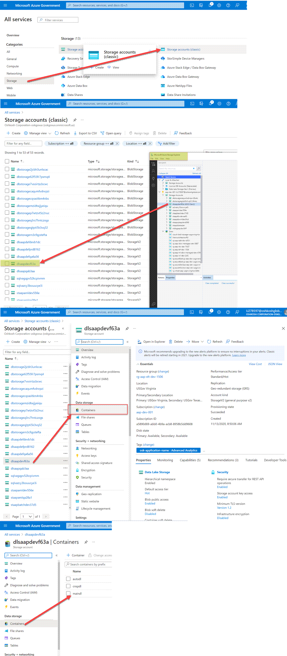

Data Factory Pipeline

Tuesday, January 11, 2022

11:52 AM

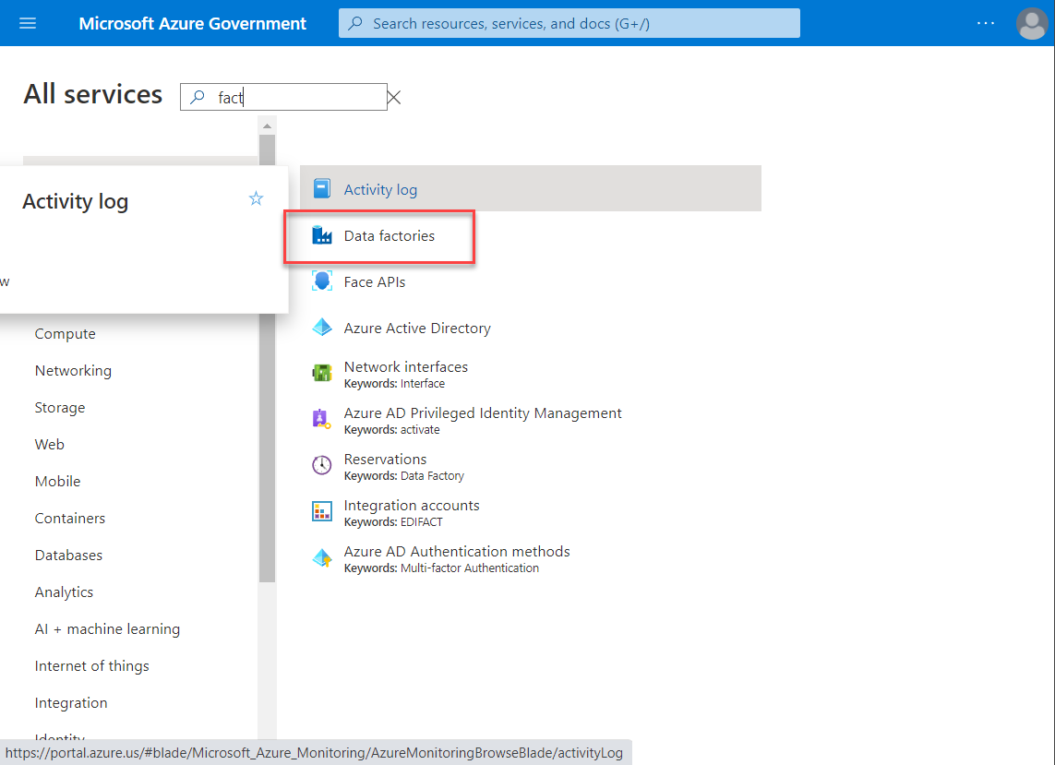

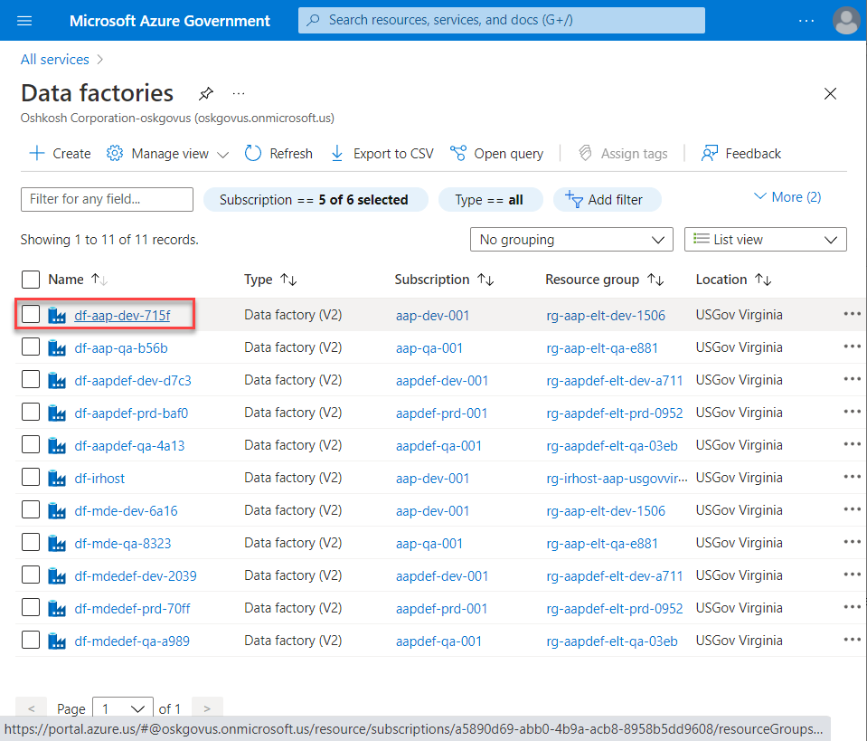

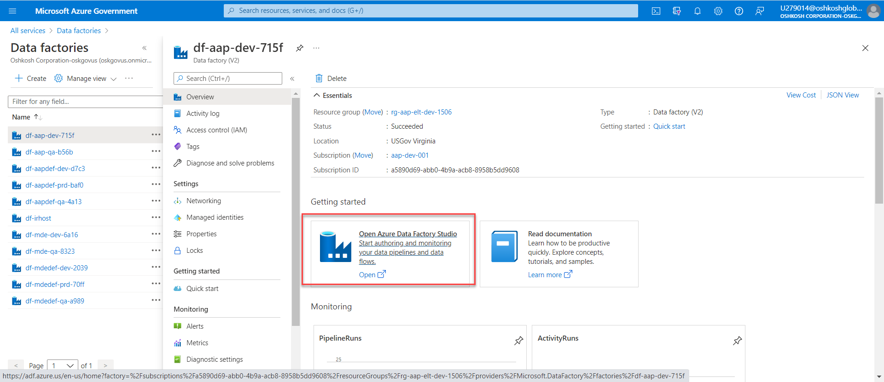

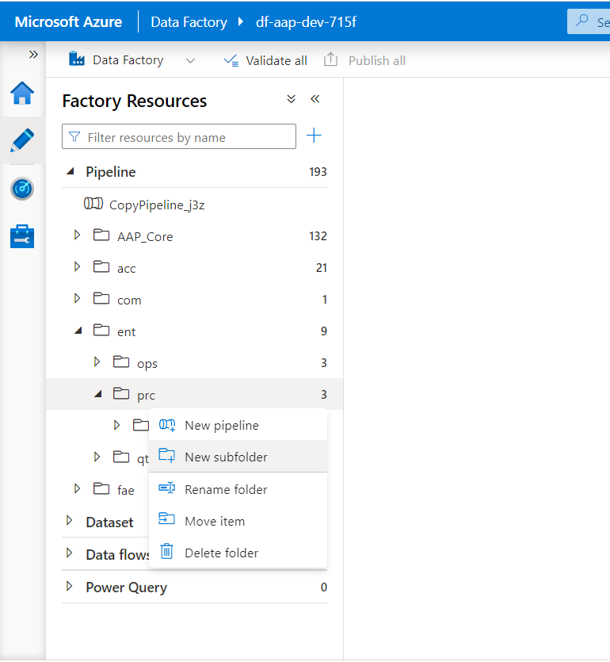

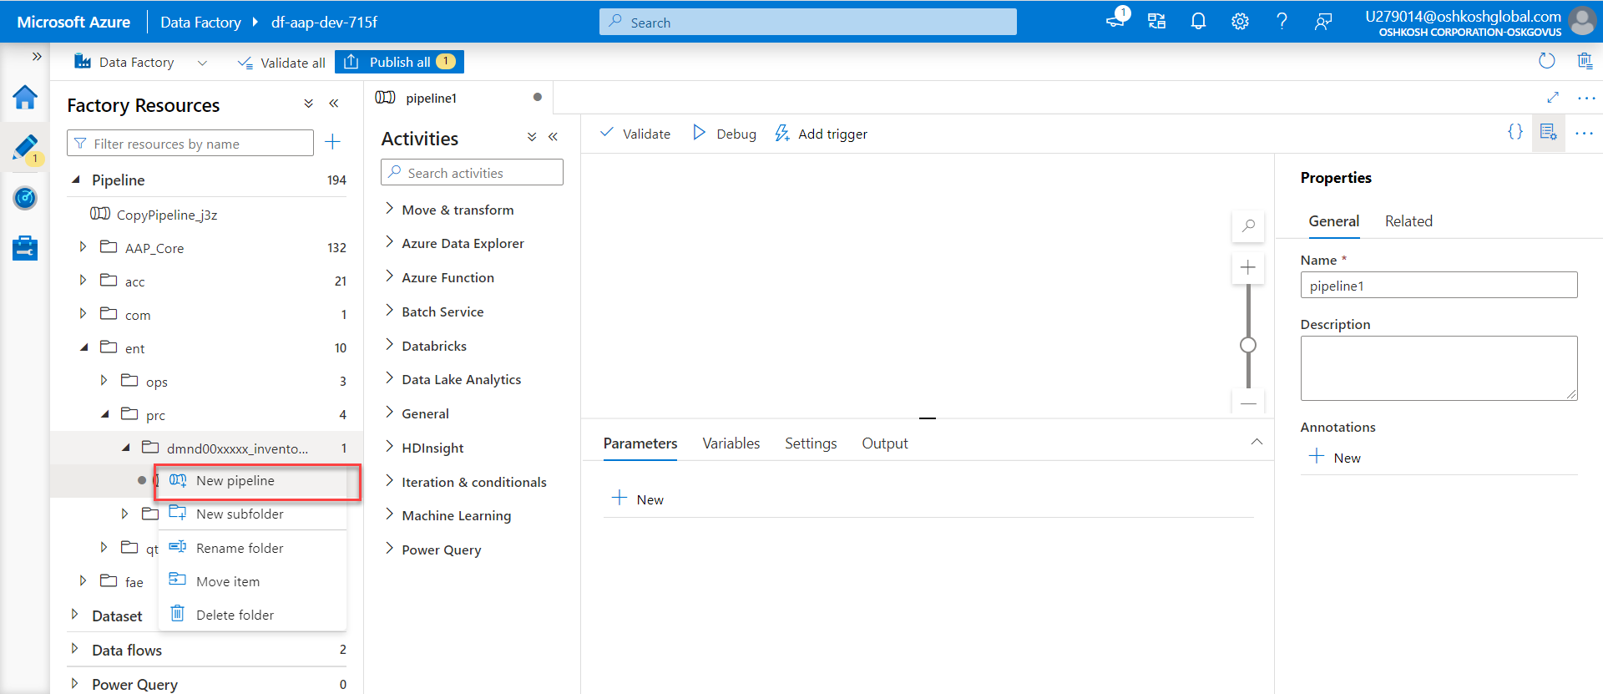

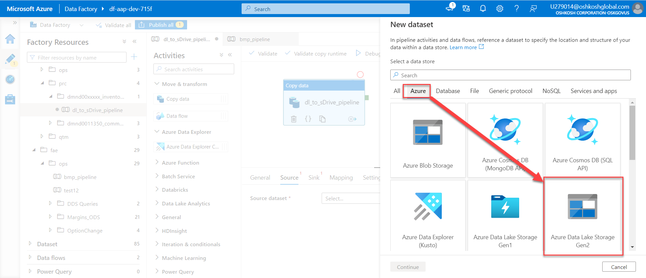

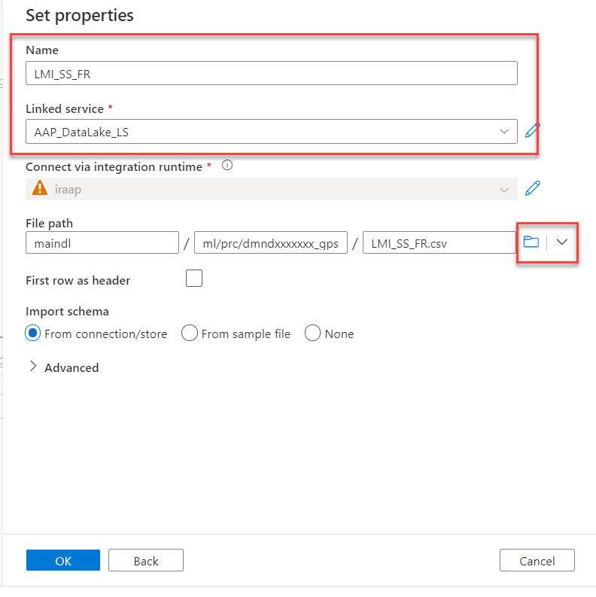

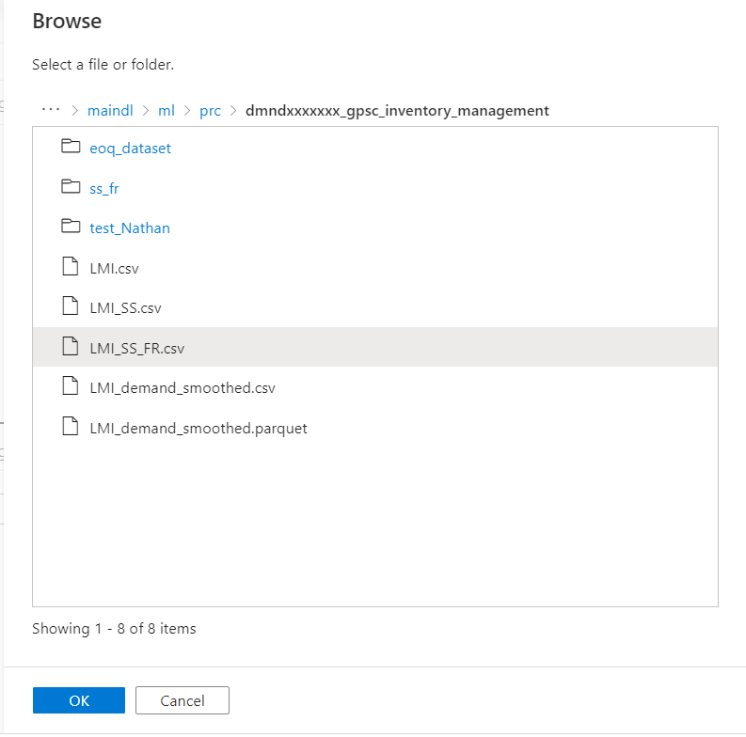

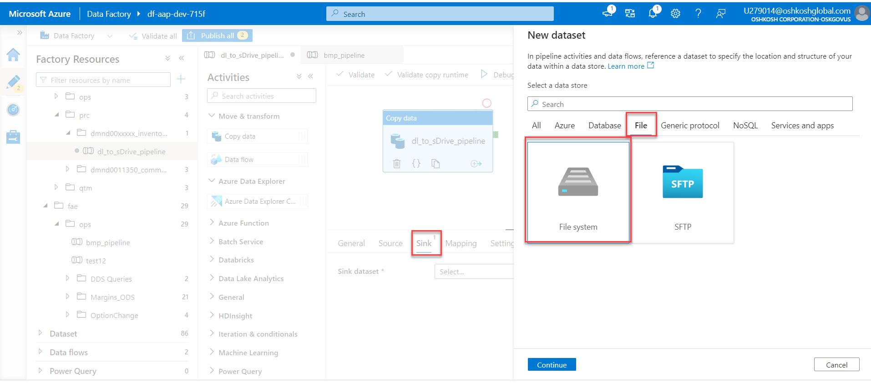

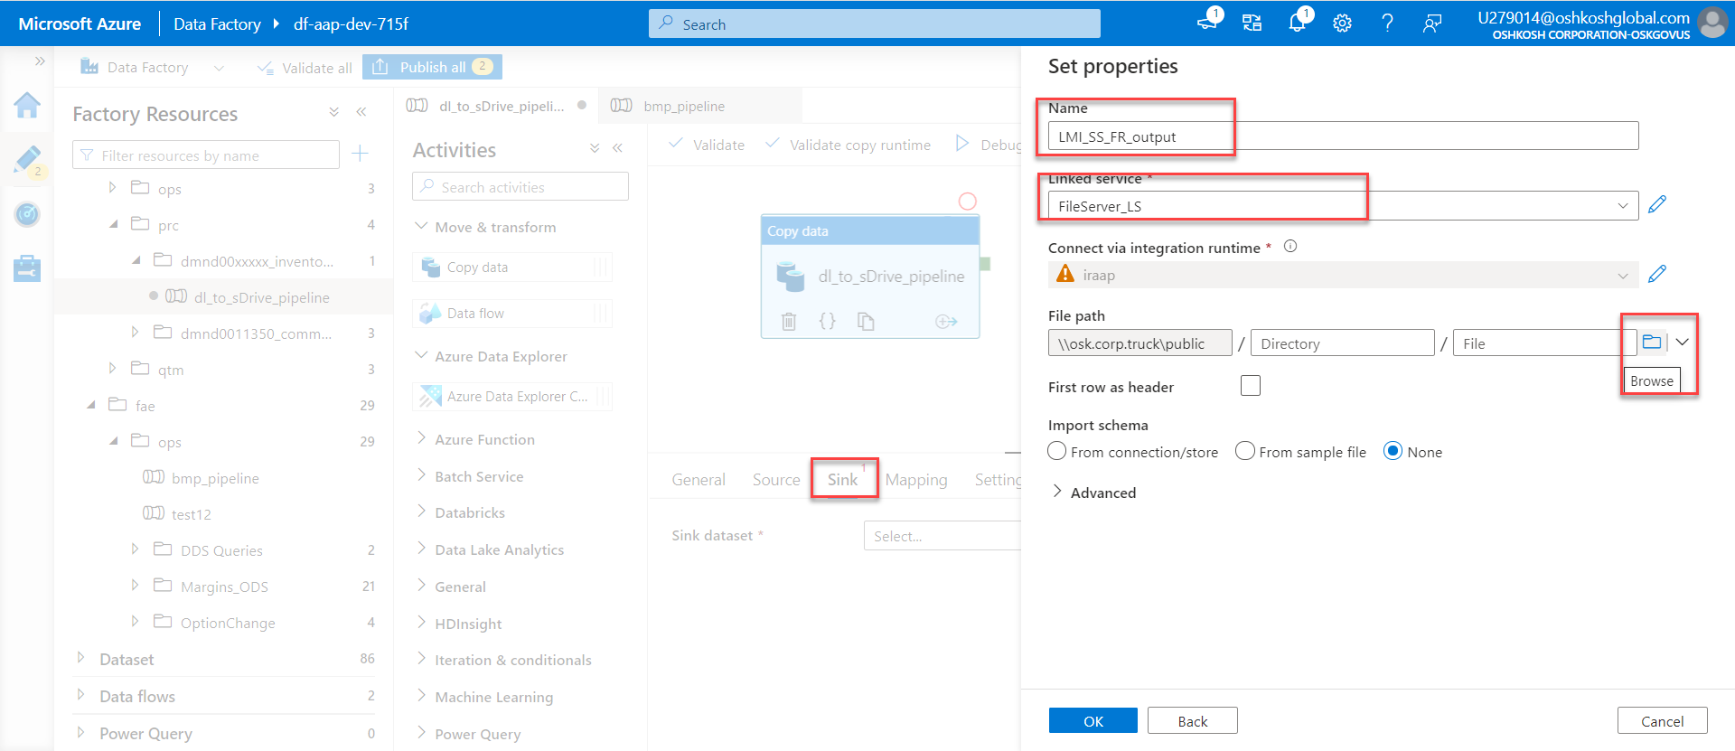

DB pipeline

Tuesday, April 12, 2022

1:49 PM

